**Re-Creation of CS Website**

**INTRODUCTION:**

Based on given 2 projects I choosed to work on front end development of recreation of CS website.

The techniques used to develop the project are HTML5, CSS3, JAVASCRIPT, JQUERY.

**IMPLEMENTATION:**

Coming to the implementation of every page the tags used in HTML5 are

<a> -- Anchor tag

<br> -- Break tag

<div> -- to divide a page into required block we use this tag

<h1> -- for headings

This project mainly describes a webpage, here we have many different pages as follows

**1. Home Page**

* The home page includes header and footer which is consistent for all the pages.
* This home page represents information about the college and upcoming events in the college.
* Here I used calendar (using JavaScript) to represent the current day, where the date highlight changes according to system date.
* The header also includes logo, title and search bar.
* It also includes footer which contains name, contact and copyrights.
* In this page I also used 2 column layout (CSS3) which separates content and image slider (using JavaScript).
* The background of calendar and events is designed with the help of css3 linear gradient property

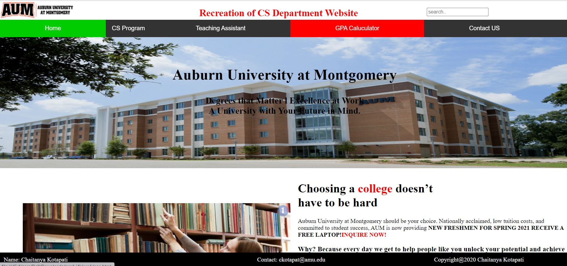

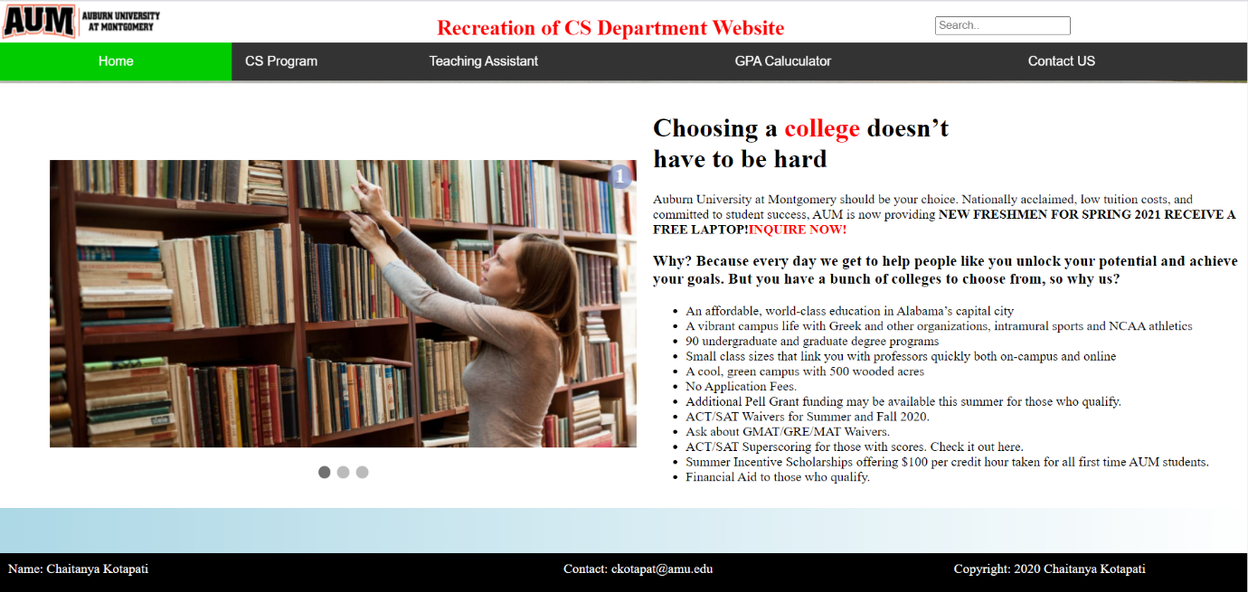

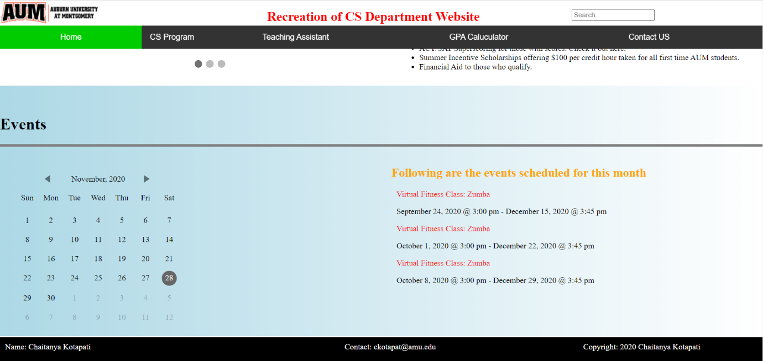

**2. CS Program: About CS Page**

* About CS page describes the cs program description ,Points to pride and motive to study.
* This page also designed with the help of 2 column layout where one column consists of entire data and another column have automatic image slider(using JavaScript).

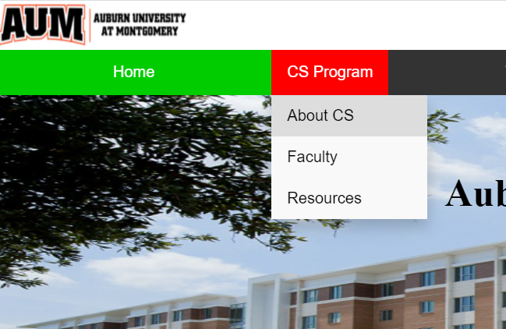

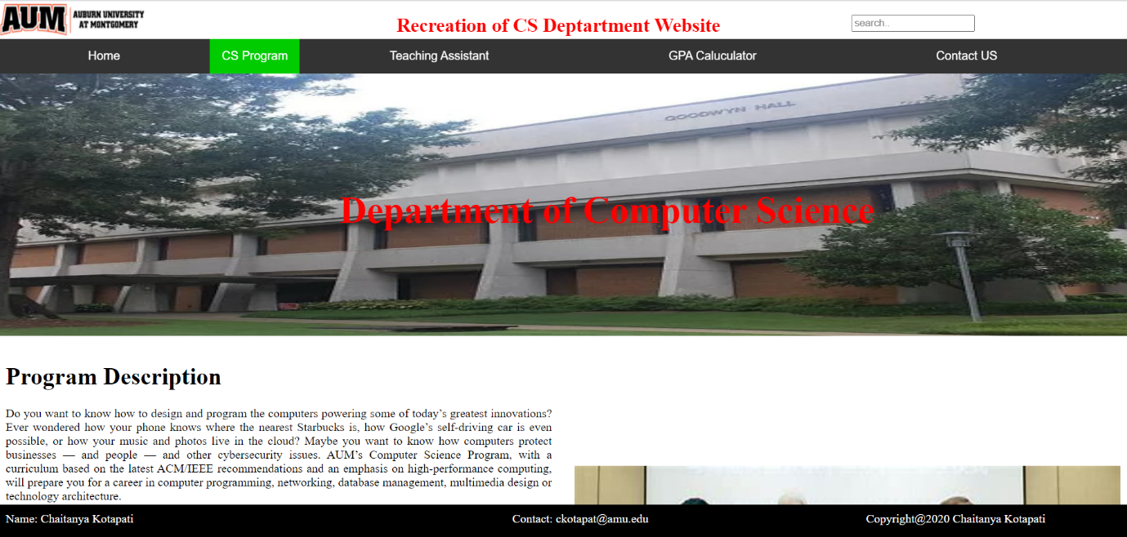

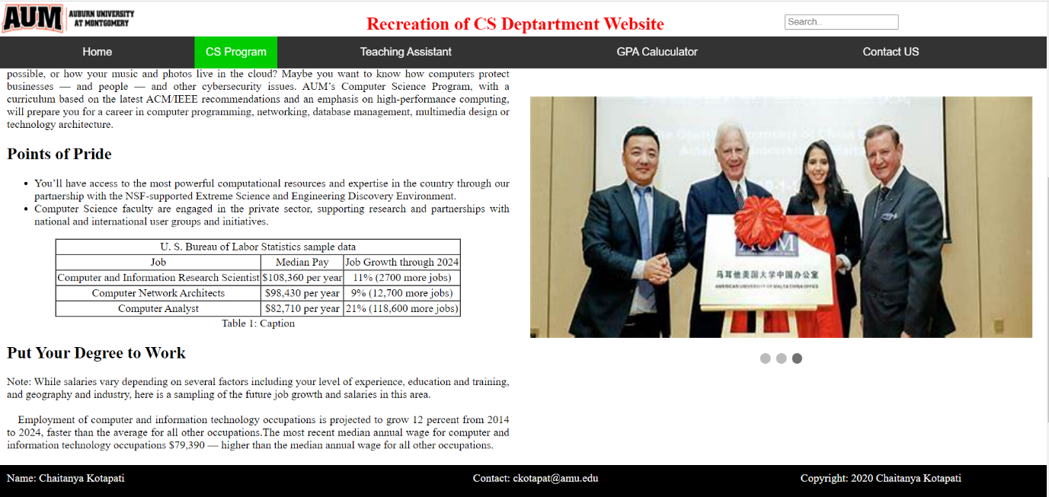

**3. Teaching Assistant Page**

* Teaching Assistant page consists of a form having name, id, gender, GPA, date, comments as form fields.
* These form fields are validated using Jquery on the client side.

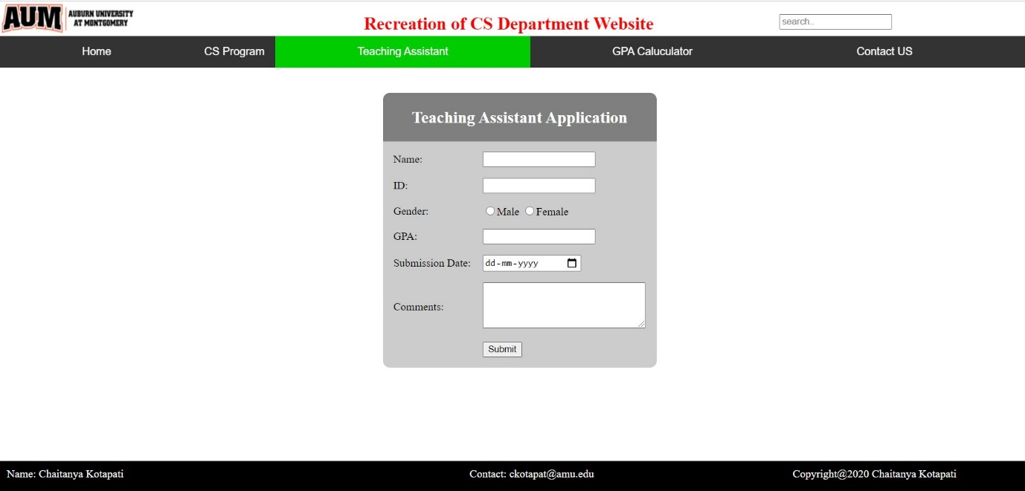

**4. GPA Calculator Page**

* GPA calculator page also consists of a Form which inputs grades for 2 courses, credits and calculates GPA.
* For calculating GPA, JavaScript is used as backend.

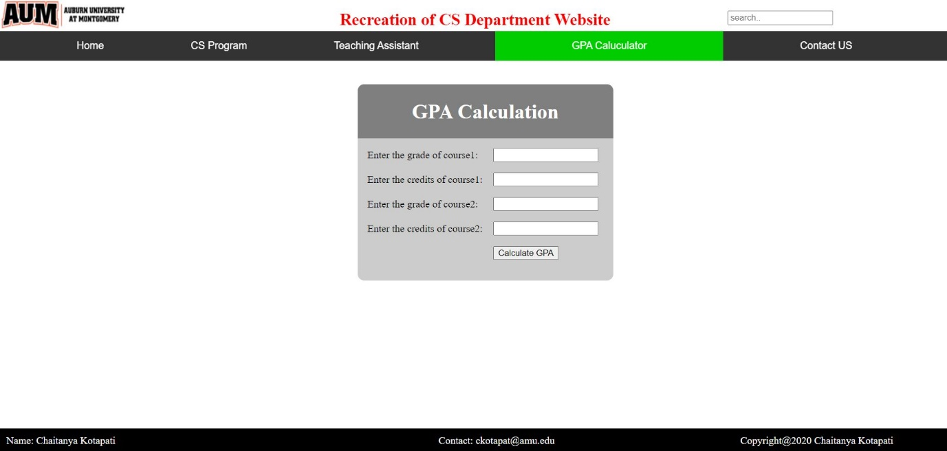

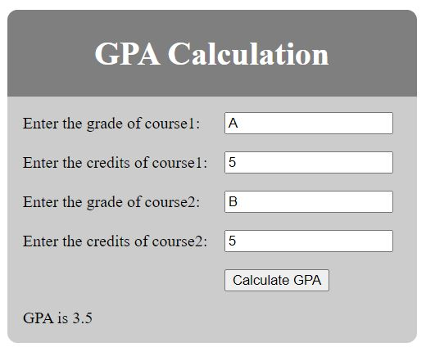

**5. Contact us page**

* The contact us page consists of a form which inputs FirstName ,Last Name, Email and comments.

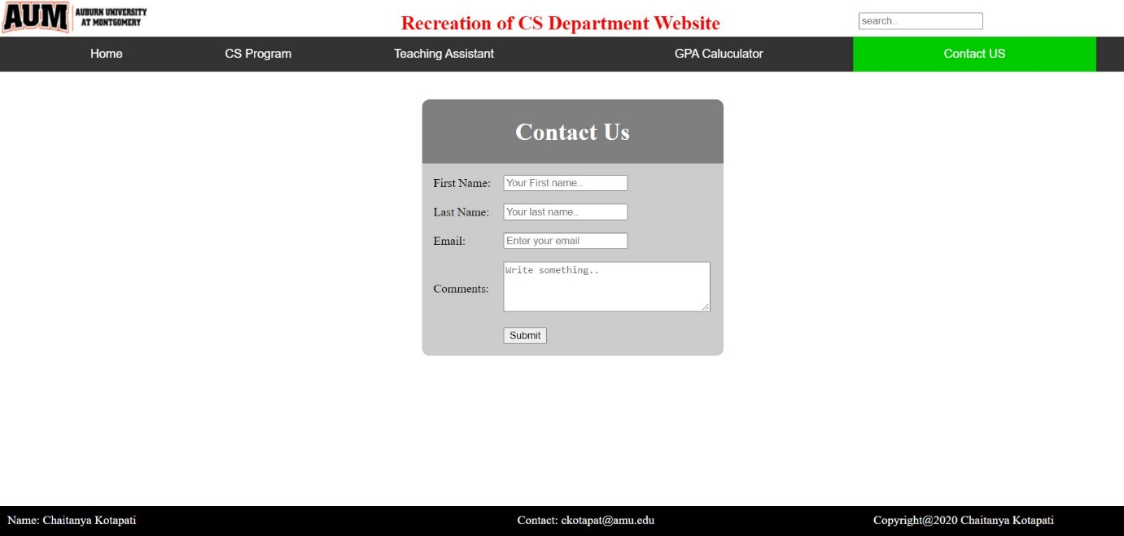

**6. Faculty page**

* Faculty page shows the faculty members of the department with name and their contact.



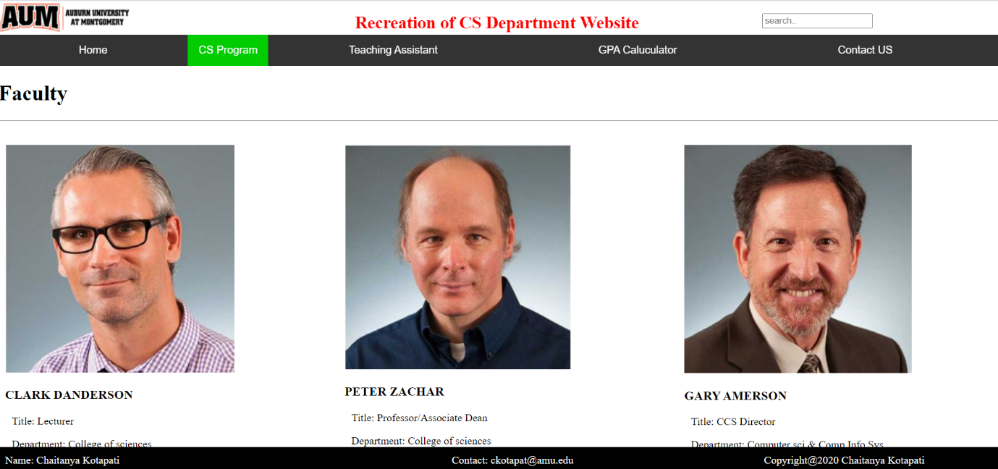

**7. Resources Page**

* This resource page shows the available facilities for the students.
* Here I used specific height and width for the images and a different layout pattern to add text below the image.



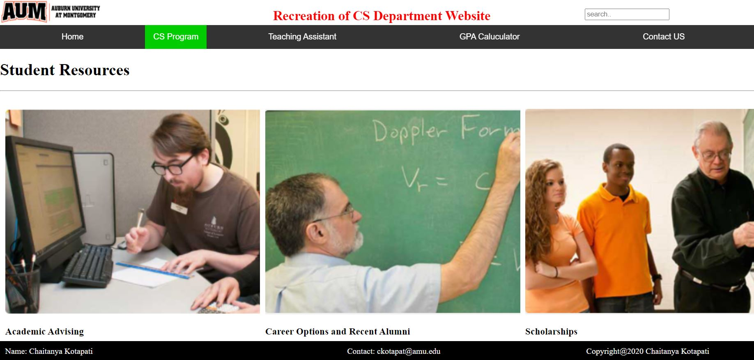

**Bonus Points**

* Included more than 2 extra pages (contact us page, faculty page, resources page).
* Used jQuery in implementing validation for form in teaching assistant page, the below image represents validation applied for the form.

